

***Quick Start Guide*** *for* ***Statistical PERT® Bootstrap Edition Version 1.0***

*First released: August 18, 2021*

***Stay Updated!***[***Join the Monthly Statistical PERT® Newsletter***](https://www.statisticalpert.com/download-free-templates/#newsletter)

*Learn about free monthly webinars, new releases, plus get tips & tricks  
for using any Statistical PERT® spreadsheet.*

***Quick Start for using a Statistical PERT® Bootstrap Edition Excel spreadsheet***

Using a Statistical PERT® spreadsheet is easy! First, [download the ***Statistical PERT® Bootstrap Edition*** example workbook for Microsoft Excel](https://www.statisticalpert.com/download-free-templates/) , and then use this ***Quick Start*** to understand the basics behind using and modifying your SPERT® spreadsheet.

This Quick Start was created from the [**Version 1.0 Statistical PERT® Bootstrap Edition** example workbook](https://www.statisticalpert.com/download/757/).

Before you download any ***Statistical PERT®*** example workbooks or templates from <https://www.statisticalpert.com>, be sure you have Microsoft Excel installed on your computer. You must be running Microsoft Excel 2010, Excel 2013, Excel 2016, Excel 2019 or Microsoft 365 (*your best experience will be with Excel 2016 or later*). **Statistical PERT is not compatible with Excel Online, Google Sheets, or other spreadsheet software programs**. Also, Excel 2013 and older cannot display histogram charts included in some SPERT® spreadsheets.

When you first open a downloaded SPERT file from the Internet, the spreadsheet opens to the **Welcome!** tab. Excel may prompt you with a Protected View notice. To use Statistical PERT, you must press the **Enable Editing** button. (You can run your computer’s virus-scanner, firstly, if you wish).

***Using the SPERT® Bootstrap Scrum worksheet***

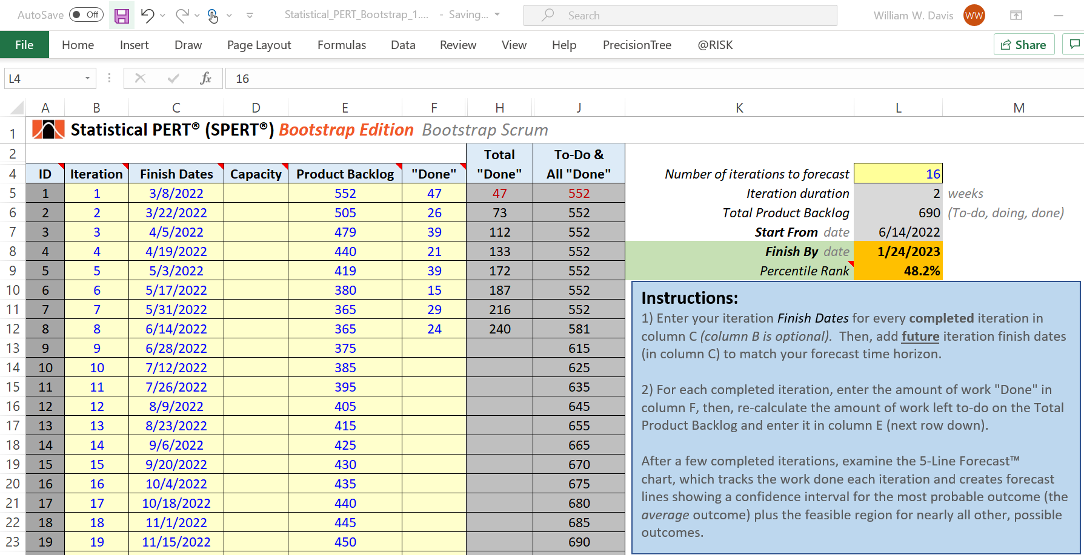

This worksheet will calculate a probable ***Finish By*** date based upon the amount work on the **Product Backlog**, the rate at which work is **“Done”**, and the number **Iterations** that are included in the forecast. This worksheet uses bootstrap simulation to calculate finish dates with different likelihoods of success.

In the example above, there is a **48.2%** chance that all the remaining work of the **Product Backlog** (450 story points in cell C23) will be finished within the next 16 iterations (***Finish By*** date of January 24, 2023).

*A Closer Look*: A Scrum Team completed their first sprint on March 8, 2022. The team works in 2-week sprints and use story point estimates to size their work efforts. This example forecast includes 36 iteration finish dates between March 8, 2022 and July 11, 2023 (note: the screenshot above only shows the first 19 iteration finish dates). The Scrum Team has finished eight sprints and has logged how much work they got **“Done”** in column F. Each time they complete a sprint, they log what was done for that sprint in column F and recalculate how much work is left to do in the **Product Backlog** so they can enter that in column E.

Since the Scrum Team finished their 8th sprint (which ended on June 14, 2022), they entered how much work they got done for the just-completed sprint in cell F12 (24 story points), recalculated how much work is left on their Product Backlog, and entered that amount in cell E13 (375 story points). Note that when they began working together, the Product Backlog initially had 552 units of work (cell E5).

In column F, the Scrum team has recorded how much work they completed over eight iterations. The **Total “Done”** work is calculated in column H. The remaining work in the **Product Backlog** to complete in future iterations is tracked in column E. The example shows an option of showing *expected* Product Backlog growth over time (cells E13:E23); the alternative approach is to enter what’s remaining in the Product Backlog (cell E13) without showing the expected growth of the Product Backlog over time (to do that, just leave cells E14:E23 blank).

Now, press F9 to recalculate the spreadsheet formulas and then start experimenting with different forecast horizon lengths in cell L5.

When you choose a forecast horizon length *that results in some likelihood of completing all the work of the Product Backlog*, then a percentile between 0% and 100% will appear in cell L9. When a percentile is displayed in cell L9, it is the percentile of 1000 simulated trials where the entire Product Backlog was finished by the ***Finish By*** date in cell L8. The ***Finish By*** date is automatically calculated for you based upon the integer value you entered in cell L5 that indicates your forecast time horizon.

The shorter your forecast horizon length is (and the smaller the value in cell L5), the fewer simulated trials will have completed all the work of the Product Backlog and the smaller the percentile will be in cell L9. Conversely, the longer your forecast horizon length is (and the larger the value in cell L5), the more simulated trials will have completed all the work of the Product Backlog and the larger the percentile will be in cell L9.

To calculate a probabilistic finish date for the remaining work in the Product Backlog, first examine right-side of the worksheet to find table cells which are highlighted in magenta. This table data identifies five different probabilistic finish dates using the simulated data in the *BootstrapData*worksheet:

* **10%** - this is a highly optimistic forecast where there is a 10% chance of completing this amount of work (or more) *in every iteration*
* **Optimistic** – this shows an optimistic (5th percentile) calculation of the bootstrapped mean
* **Expected** – this shows the most likely (50th percentile) calculation of the bootstrapped mean
* **Conservative** – this shows a conservative (95th percentile) calculation of the bootstrapped mean
* **90%** - this is a highly conservative forecast where there is a 90% chance of completing this amount of work (or more) *in every iteration*

***Using the SPERT® Bootstrap Kanban worksheet***

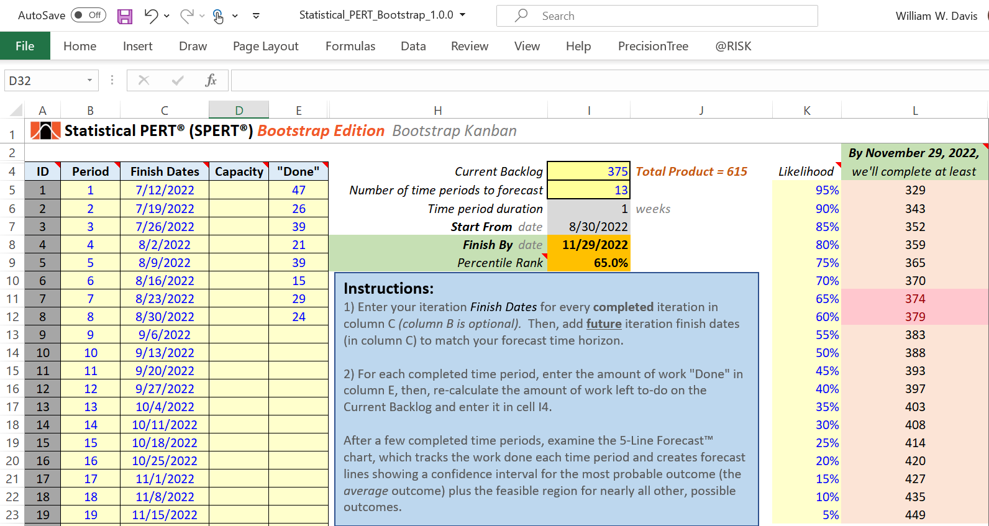

The Bootstrap Kanban worksheet works very similarly to the Bootstrap Scrum worksheet. The primary difference is that this worksheet does not track the rising and falling Product Backlog line over time; instead, it’s just a horizontal line showing the sum of all **“Done”** work (column E) and remaining work left to do (cell I4). Otherwise, this worksheet performs very similarly in the way you create a forecast for a Scrum Team.

Note: Although many Kanban teams track their completed work items *daily*, this forecasting model is intended to work with *weekly* time intervals or greater. Teams that track completed *daily* work items can simply sum their *daily* totals to arrive at a *weekly* totals for this forecasting model.

***Using the SPERT® Vlookups worksheet***

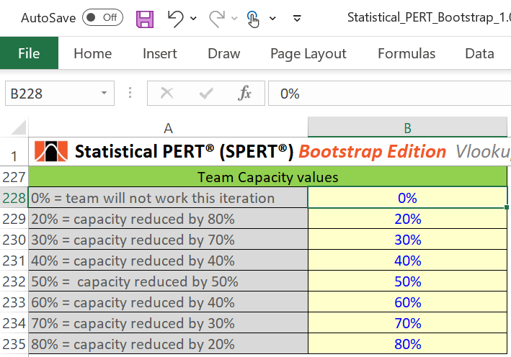

For the most part, you will not need to modify the lookup values in the Vlookups worksheet. Most of the lookup tables are used to dynamically control how much simulated data to use during the bootstrapping simulation process.

There is one lookup value you might choose to modify: the **Team Capacity** values. In this table, you can choose different team capacity values to indicate reduced team capacity, as shown in the example above. Another option is to indicate *increased* team capacity where the existing team capacity might be greater than 100%—this this might occur if a team scales upward to include new team members and/or new teams working on the same product backlog. Values in column B are used for the Team Capacity lookup in the Bootstrap Scrum and Bootstrap Kanban worksheets. Explanatory notes in column A are informational only and not used in any VLOOKUP functions.

***Get More Information on Statistical PERT®***

There are many ways to get more information about Statistical PERT. Visit the Statistical PERT website at <https://www.statisticalpert.com> and click on the [Learn More](https://www.statisticalpert.com/learn-more/) tab to get more information about Statistical PERT. Also, click on the [News & Blog](https://www.statisticalpert.com/news-blog/) tab to get access to blogs and new information about Statistical PERT.

***Have any Questions? Find a Bug? Want to Connect?***

Email: [famousdavispmp@gmail.com](mailto:famousdavispmp@gmail.com)

LinkedIn: <https://www.linkedin.com/in/famousdavis>

Twitter: <https://twitter.com/StatisticalPERT>

YouTube: <https://www.youtube.com/StatisticalPERT/>

***Stay Updated!***[***Join the Monthly Statistical PERT® Newsletter***](https://www.statisticalpert.com/download-free-templates/#newsletter)

*Learn about free monthly webinars, new releases, plus get tips & tricks  
for using a Statistical PERT® spreadsheet.*

